**Advance Excel Assignment 1**

**1.What do you mean by cells in an Excel sheet ?**

**Ans:-** Cells are the boxes you see in the grid of an Excel worksheet, like this one. Each cell is identified on a worksheet by its reference, the column letter and row number that intersect at the cell's location. This cell is in column D and row 5, so it is cell D5. The column always comes first in a cell reference.

**2)How can you restrict someone from copying a cell from your worksheet** ?

**Ans:-** 1. First, choose the data you want to protect.

2. Hit Ctrl + Shift + F. The Format Cells tab appears. Go to the Protection tab. Check Locked and click OK.

Next, go to the Review tab and select Protect Sheet. Enter the password to protect the sheet.

**3)How to move or copy the worksheet into another workbook ?**

### **Ans:- Method 1. Copy Excel sheet by dragging**

Usually, you drag-and-drop to move something from one place to another. But this method also works for copying tabs and is, in truth, the fastest way to copy a sheet in Excel.

Simply, click on the sheet tab that you want to copy, hold the Ctrl key and drag the tab where you want it:

### **Method 2. Duplicate a sheet by right-clicking**

Here's another way to duplicate a sheet in Excel that is just as easy:

1. Right click on the tab and select **Move or Copy** from the context menu. This will open the Move or Copy dialog box.
2. Under Before sheet, choose where you want to place the copy.
3. Put a tick in the **Create a copy** box.
4. Click OK.

### **Method 3. Copy a tab in Excel using the ribbon**

The ribbon contains all the features available in Excel, you just need to know where to look :)

To copy a sheet, go to the Home tab > Cells group, click Format, and then click **Move or Copy Sheet**:

The common way to copy a sheet to another workbook is this:

1. Right click on the tab that you want to copy, and then click **Move or Copy…**
2. In the Move or Copy dialog box, do the following:
   * Under To book, choose the target file. To place a copy into a new workbook, select (new book).
   * Under Before sheet, specify where to put the copy.
   * Select the **Create a copy** box.
   * Click OK.

**4) Which key is used as a shortcut for opening a new window document ?**

**Ans:- Ctrl+N**

**5)What are the things that we can notice after opening the Excel interface ?**

**Ans :-** 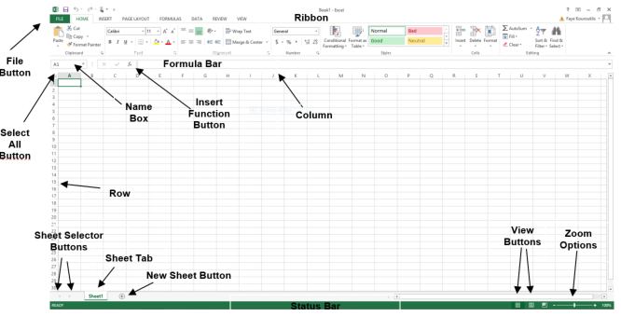

|  |  |
| --- | --- |
| **Interface Element** | **Description** |
| Ribbon Tabs | Ribbon Tab is a tab that organizes commands by topic |
| The Ribbon | Commands underneath the Tabs |
| Ribbon Groups | Grouping of related commands |
| Dialog Box Launcher | Opens a dialog box that includes additional commands |
| Quick Access Toolbar | One click access to any frequently used command |
| Name Box | Displays cell location and can be used to navigate to a cell location |
| Select All Button | Selects all the cells in a worksheet |
| Formula Bar | View, enter, or edit cell contents |
| Insert Function Button | Displays Insert Function dialog box |
| Scroll Bars | Used to navigate up, down, left & right |
| Zoom Slider | Zoom into an area of the worksheet |
| View Buttons | Switch between Normal, Page Layout and Page Break Preview views |
| Worksheet tabs | Tabs used to select individual worksheets |
| The Workspace | The area inside of the columns and rows used in Excel |
| Columns | Columns use letters |
| Rows | Rows use numbers |

**6) When to use a relative cell reference in Excel ?**

**Ans :-** Relative references are especially convenient whenever you need to repeat the same calculation across multiple rows or columns

By default, all cell references are **relative references**. When copied across multiple cells, they change based on the relative position of rows and columns. For example, if you copy the formula **=A1+B1** from row 1 to row 2, the formula will become**=A2+B2.**Relative references are especially convenient whenever you need to **repeat** the same calculation across multiple rows or columns.